

|  |  |
| --- | --- |
| **Web technologies | Front-End** | |
| Student(s’) name(s): | Adema Bauyrzhankyzy  Beibars Anuarov |
| Teacher name: | Dariya Bissengaliyeva |
| Project name: | Specialized websites for city guests and tourists |
| Project type: | Group |

**INTRODUCTION**

*Our city is getting bigger and bigger every day. There are more and more places for visitors and tourists to visit in the city. Of course, in the current developed time there are all sorts of card services and so on, but adults do not often know how to use them. We offer websites separately for each cultural object, so that the visit is much easier and organized, and also provide guide services and purchase tickets to certain places (for example, the Nur Alem Museum).*

**MAIN PART (Practical) | Information about developers and their responsibilities.**

*To make our idea more understandable, we immediately showed it on the example of the EXPO 2017 pavilion. Here is our website separately for the EXPO pavilion. The main page is informative. Each object located on the pavilion is painted with its own description and people can go further, that is, click on the object they want to visit and order a special tour, or make an online purchase of the required number of tickets for the room.*

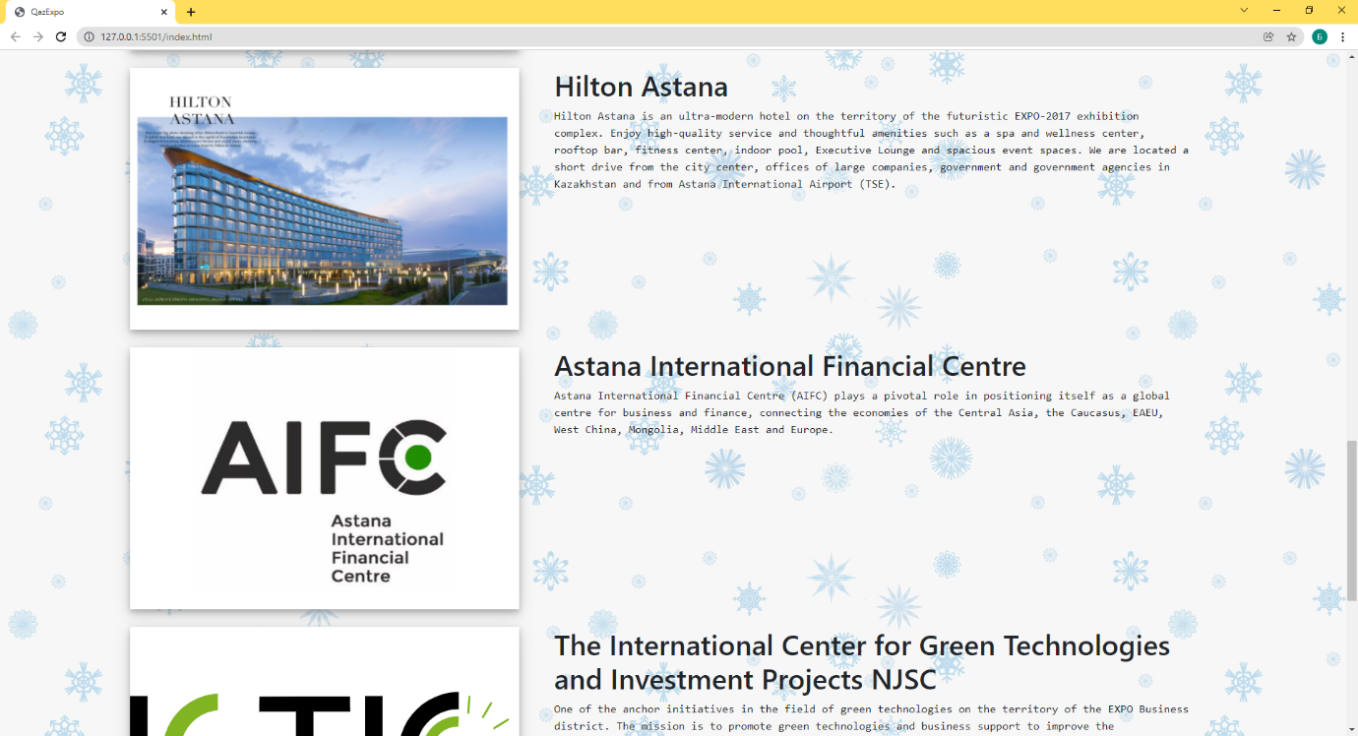

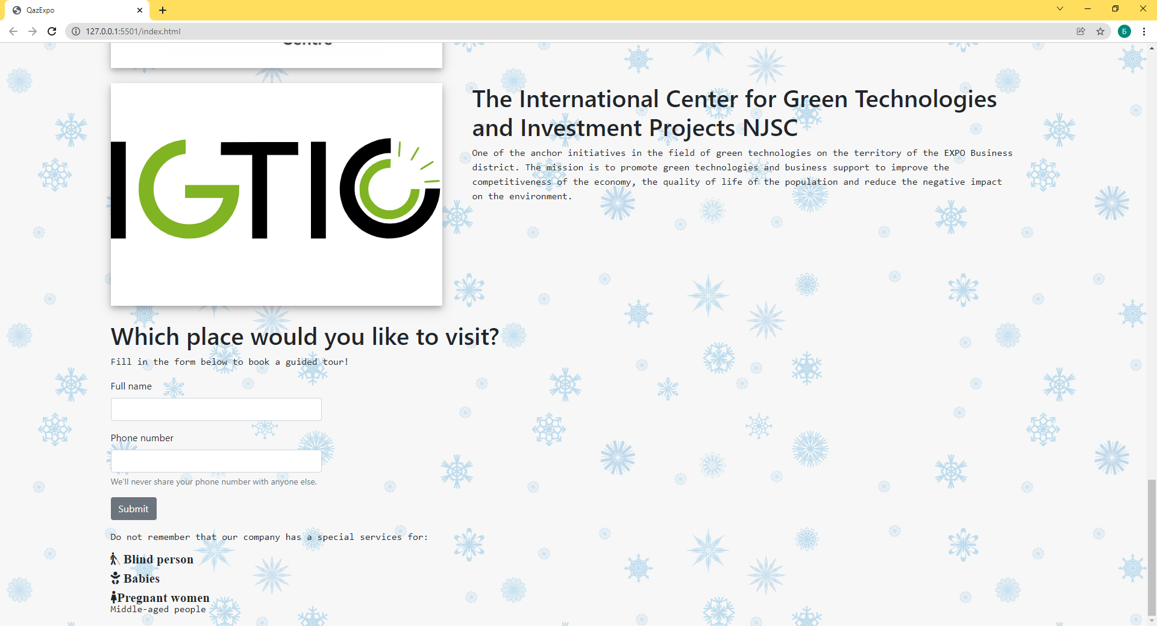

*At the top there are navigation bars like "Home", "Companies" and "Contacts". First of all, we added a page of one of the objects located on the territory of the pavilion - Astana Hub. It is not finished, but ideas are still available. We have also added separate web pages for "Companies" and "Contacts".*

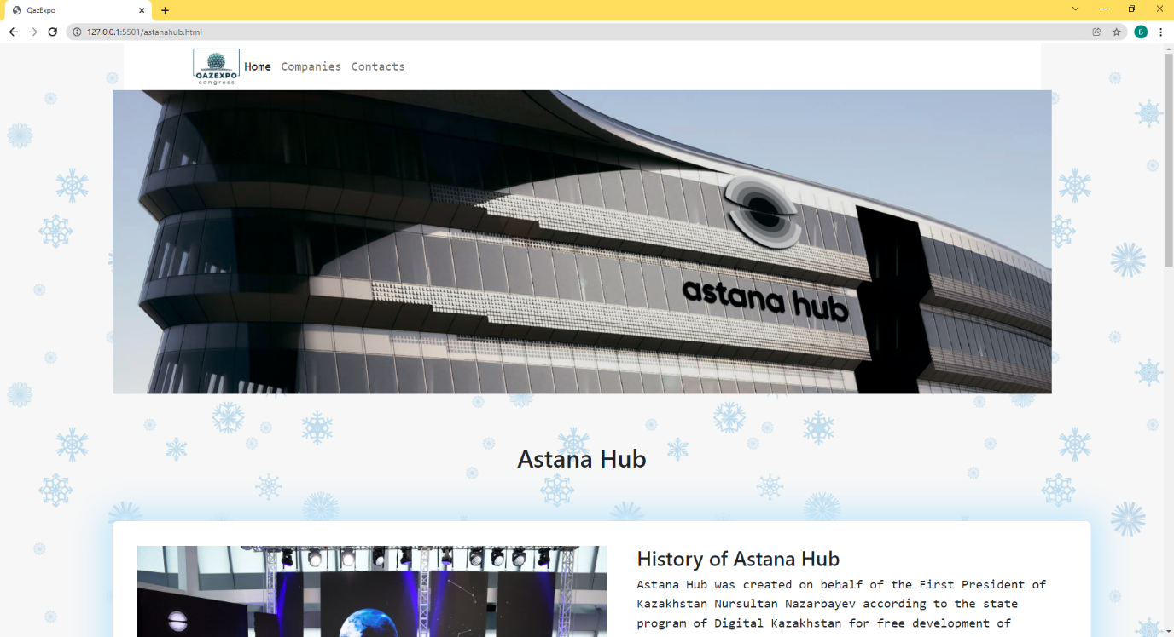

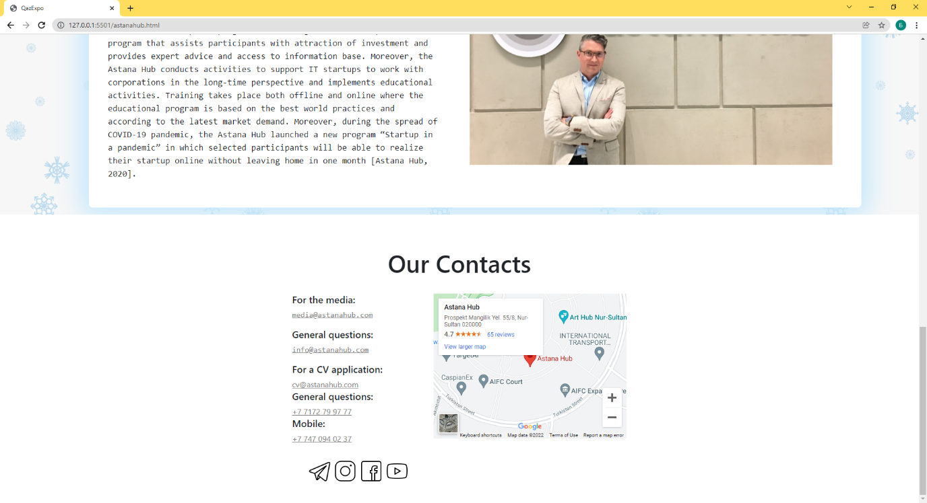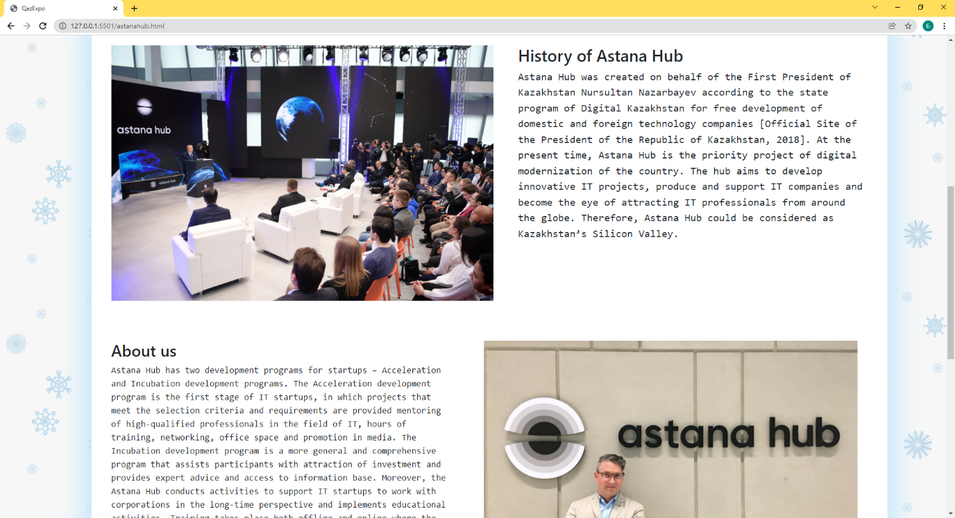

*"Contacts" will be in each special site for various cultural objects. We have provided for this in case of various unforeseen situations. And also added a window for people who had some problems related to our services, or for feedback and suggestions to improve the quality.*

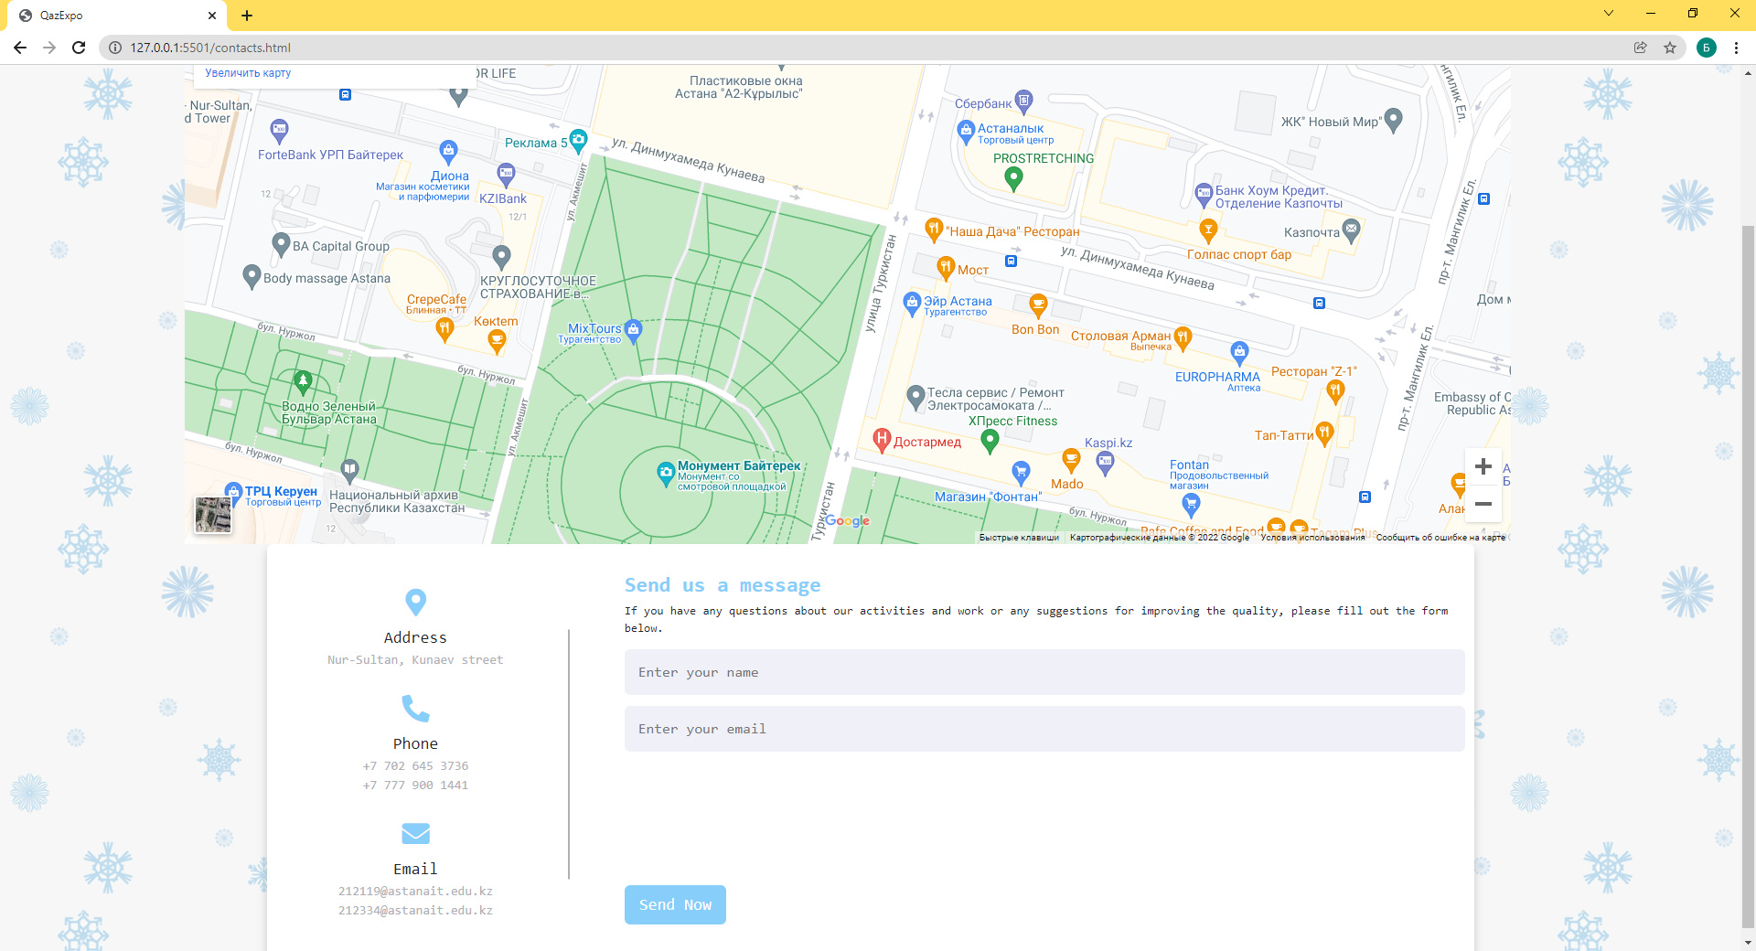

*"Companies" is a separate website that will not be linked to other pages that we will make yet. It can be described as an additional page of our services for companies and cultural sites.*

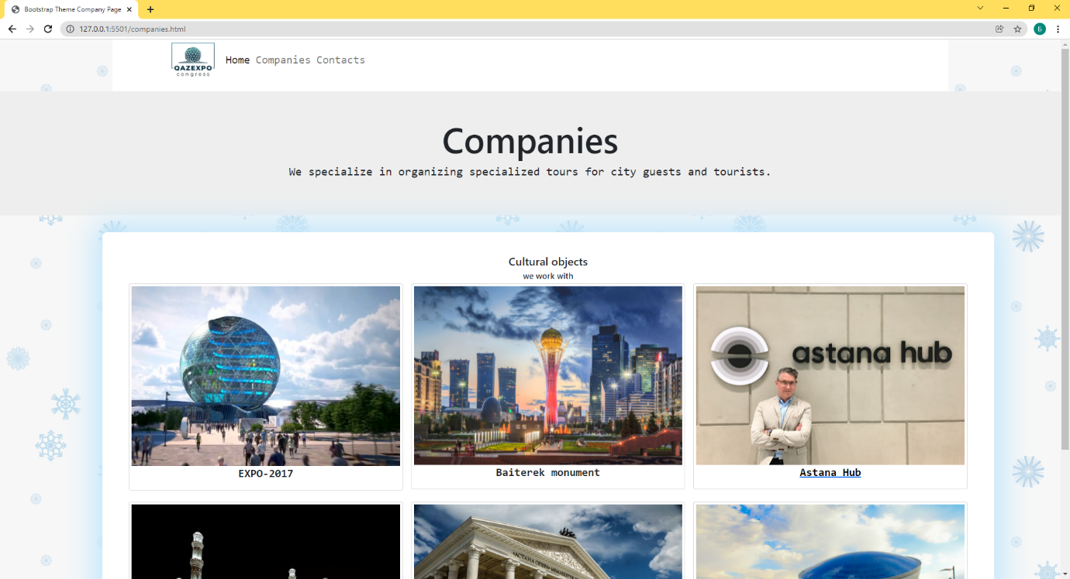

**PROGRESS [optional]**

|  |  |
| --- | --- |
| 24.12.2021 | Basic HTML. HTML components: input, buttons, forms  elements, div elements, tables. |
| 25.12.2021 |
| 31.12.2021 | Styles, colors, position, spacing, alignment, fonts, classes, CSS static, relative and absolute positioning systems. |
| 01.01.2022 |
| 07.01.2022 | Bootstrap grid layout system, bootstrap containers, components such as buttons. |
| 08.01.2022 |
| 14.01.2022 | Bootstrap carousels, Bootstrap cards, navigation bars. |
| 15.01.2022 |
| 21.01.2022 |  |
| 22.01.2022 |
| 28.01.2022 |  |
| 29.10.2022 |
| 04.02.2022 |  |
| 05.02.2022 |
| 11.02.2022 |  |
| 12.02.2022 |
| 18.02.2022 |  |
| 19.02.2022 |
| 25.02.2022 |  |
| 26.02.2022 |